Spearman rank correlation: USDCHF and USDCAD
Method 02 / daily log returns / Alpari D1 full available history

Study setup
Logical pair: USDCHF , USDCAD
Broker symbols: USDCHF_i , USDCAD_i
Snapshot: 2026-11-03_majors_alpari_D1
Timeframe: D1
Matched return window: 1999-01-05 to 2026-11-02 (UTC bar dates)
Matched return count n: 7188
Dropped unfinished last bar dated 2026-11-03 UTC after a tick-volume check against the prior complete day.
Complete matched rows (CSV): USDCHF-USDCAD_Spearman_D1.csv
Complete matched rows (HTML table): USDCHF-USDCAD_Spearman_D1_data.html

Method carried forward
Spearman rho is Pearson correlation on the ranks of matched daily log returns of close, ln(close_t / close_t-1), in the broker quote direction. Ties use average ranks. Quotes are not inverted. rho is symmetric under swap of the two symbols. rho = 0 means no consistent rank-order link in this sample; it does not mean no link of any kind. The score is not a cause, not a lead, and not a trading signal. Daily rows are not independent draws, so the two-sided p-value and approximate Fisher interval are reported and treated as secondary to rho. Same-sample Pearson r is shown only as a side check; a large rho minus r gap can flag outliers or a non-straight link.

Results
Spearman rho: 0.329543
Two-sided p-value: 1.17217e-181
Approximate 95% Fisher interval: [0.308777, 0.349995]
Same-sample Pearson r: 0.304665
rho minus r: 0.024878

Conclusion
Over 7188 matched daily log-return rows for USDCHF and USDCAD (broker quote directions unchanged), Spearman rho is 0.3295 (positive, weak rank-order association in this sample). Approximate 95% Fisher interval: [0.3088, 0.3500]. Same-sample Pearson r is 0.3047 (rho minus r = 0.0249). Two-sided p under the usual independent-ranks model is 1.172e-181; that model does not match linked daily FX returns, so treat p as secondary. This does not establish cause, lead-lag, or a lasting trading rule.

Charts
Daily closes

Daily log returns
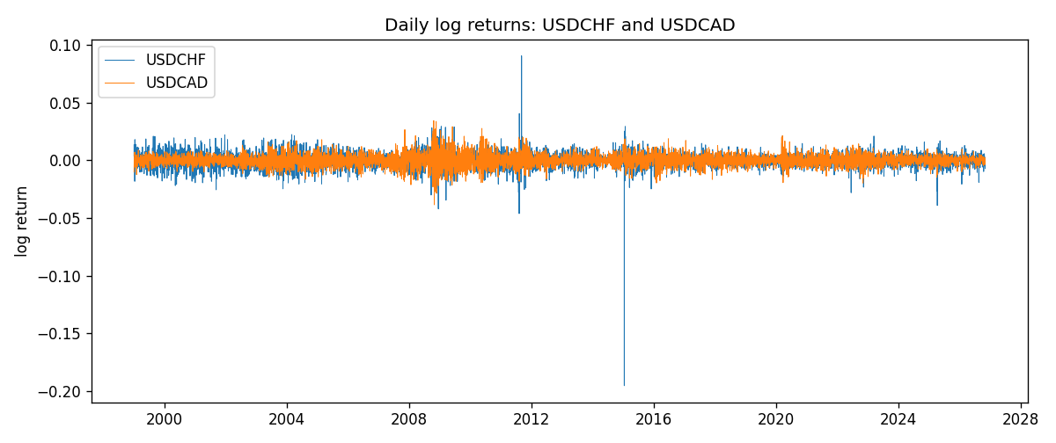
Log-return scatter
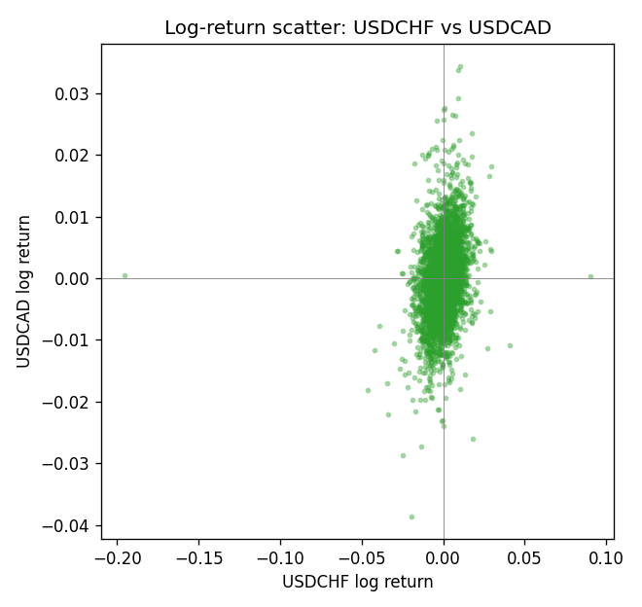
Rank-rank scatter
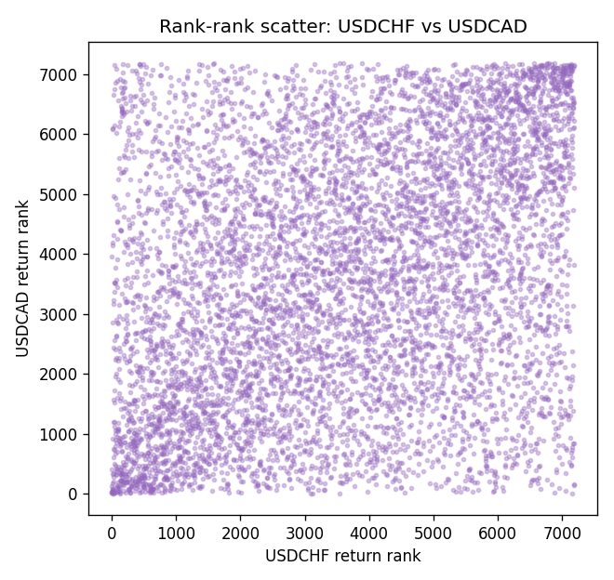

Data report
Every matched row that entered Spearman rho is stored in the sibling CSV named USDCHF-USDCAD_Spearman_D1.csv. That file is the complete data archive for redrawing charts. Embedding all rows as a Word table is impractical at this length; the Word file holds the column list, column summaries, and the first and last 15 matched rows.
Columns: time, USDCHF_open, USDCAD_open, USDCHF_high, USDCAD_high, USDCHF_low, USDCAD_low, USDCHF_close, USDCAD_close, USDCHF_tick_volume, USDCAD_tick_volume, USDCHF_spread, USDCAD_spread, USDCHF_real_volume, USDCAD_real_volume, USDCHF_log_return, USDCAD_log_return
Column summaries (matched calculation rows)
column | count | mean | std | min | 25% | 50% | 75% | max
USDCHF_open | 7188 | 1.0975966 | 0.25229688 | 0.72022 | 0.9205375 | 0.989955 | 1.2378 | 1.8219
USDCAD_open | 7188 | 1.2667824 | 0.16892678 | 0.9168 | 1.1183975 | 1.298465 | 1.3720475 | 1.6183
USDCHF_high | 7188 | 1.1028875 | 0.2540352 | 0.73305 | 0.924845 | 0.993545 | 1.242375 | 1.8313
USDCAD_high | 7188 | 1.2716804 | 0.16888565 | 0.9336 | 1.12285 | 1.30387 | 1.37646 | 1.619
USDCHF_low | 7188 | 1.0924772 | 0.25071604 | 0.08565 | 0.91725 | 0.9863 | 1.23155 | 1.8121
USDCAD_low | 7188 | 1.2622243 | 0.16896256 | 0.9056 | 1.114065 | 1.293535 | 1.3677775 | 1.6102
USDCHF_close | 7188 | 1.0975873 | 0.25219296 | 0.72025 | 0.920805 | 0.98995 | 1.2379 | 1.8217
USDCAD_close | 7188 | 1.2667976 | 0.16890032 | 0.916 | 1.118075 | 1.29844 | 1.372365 | 1.6137
USDCHF_tick_volume | 7188 | 74305.244 | 113479.97 | 1 | 12787.25 | 40220 | 70419.75 | 858589
USDCAD_tick_volume | 7188 | 81017.898 | 147302.44 | 1 | 5560 | 40941.5 | 71627 | 1410818
USDCHF_spread | 7188 | 26.050501 | 24.7086 | 0 | 5 | 16 | 50 | 100
USDCAD_spread | 7188 | 23.4399 | 18.261108 | 0 | 9 | 17 | 40 | 60
USDCHF_real_volume | 7188 | 2.3284369e+10 | 8.9116261e+10 | 0 | 0 | 0 | 0 | 1.9331921e+12
USDCAD_real_volume | 7188 | 1.8376704e+10 | 9.6688094e+10 | 0 | 0 | 0 | 0 | 2.5751613e+12
USDCHF_log_return | 7188 | -7.133e-05 | 0.00659527 | -0.19545699 | -0.0033544 | 8.077e-05 | 0.00332477 | 0.09051364
USDCAD_log_return | 7188 | -1.556e-05 | 0.00514382 | -0.03859748 | -0.00283746 | 4.44e-05 | 0.00272629 | 0.03436319
First 15 matched rows (selected columns)
time | USDCHF_close | USDCAD_close | USDCHF_log_return | USDCAD_log_return | USDCHF_tick_volume | USDCAD_tick_volume
1999-01-05 | 1.3724 | 1.5123 | 0.0039424743 | -0.010131666 | 4666 | 1345
1999-01-06 | 1.3912 | 1.5118 | 0.013605652 | -0.0003306769 | 3740 | 1803
1999-01-07 | 1.3782 | 1.5141 | -0.0093883841 | 0.0015202092 | 4262 | 1568
1999-01-08 | 1.3935 | 1.511 | 0.011040268 | -0.0020495197 | 5991 | 914
1999-01-11 | 1.4009 | 1.5057 | 0.0052963193 | -0.0035137769 | 5236 | 953
1999-01-12 | 1.3872 | 1.5157 | -0.0098275602 | 0.0066194721 | 5975 | 1507
1999-01-13 | 1.3621 | 1.5226 | -0.018259701 | 0.0045420214 | 7036 | 2141
1999-01-14 | 1.3588 | 1.5332 | -0.0024256692 | 0.0069376546 | 5825 | 1816
1999-01-15 | 1.3834 | 1.5245 | 0.01794228 | -0.0056905671 | 7434 | 1897
1999-01-18 | 1.379 | 1.526 | -0.0031856384 | 0.00098344542 | 4965 | 1091
1999-01-19 | 1.3789 | 1.5302 | -7.2518946e-05 | 0.002748513 | 5494 | 1634
1999-01-20 | 1.3889 | 1.5211 | 0.0072259871 | -0.0059646885 | 5477 | 1499
1999-01-21 | 1.3836 | 1.5146 | -0.0038232689 | -0.0042823796 | 4736 | 2007
1999-01-22 | 1.3834 | 1.5184 | -0.0001445609 | 0.0025057712 | 4833 | 1713
1999-01-25 | 1.3868 | 1.5197 | 0.0024546976 | 0.00085579808 | 3996 | 1471
Last 15 matched rows (selected columns)
time | USDCHF_close | USDCAD_close | USDCHF_log_return | USDCAD_log_return | USDCHF_tick_volume | USDCAD_tick_volume
2026-10-13 | 0.83244 | 1.4214 | -0.0024955621 | -0.0046395653 | 32763 | 50947
2026-10-14 | 0.83489 | 1.42356 | 0.0029388325 | 0.0015184751 | 40903 | 56126
2026-10-15 | 0.82676 | 1.41843 | -0.0097855323 | -0.0036101503 | 54132 | 63096
2026-10-16 | 0.82377 | 1.41357 | -0.0036230826 | -0.0034322068 | 47176 | 54908
2026-10-19 | 0.82677 | 1.41091 | 0.0036351779 | -0.0018835331 | 40610 | 52155
2026-10-20 | 0.8246 | 1.40569 | -0.0026281224 | -0.0037066008 | 42106 | 54450
2026-10-21 | 0.82427 | 1.4045 | -0.00040027413 | -0.00084691787 | 37648 | 51369
2026-10-22 | 0.82032 | 1.40081 | -0.0048036381 | -0.0026307268 | 50809 | 58806
2026-10-23 | 0.82497 | 1.40085 | 0.005652514 | 2.85545e-05 | 45872 | 50387
2026-10-26 | 0.82649 | 1.40093 | 0.0018407959 | 5.7106554e-05 | 41336 | 49601
2026-10-27 | 0.82865 | 1.40449 | 0.0026100526 | 0.0025379458 | 35560 | 49541
2026-10-28 | 0.82781 | 1.39911 | -0.0010142111 | -0.0038379274 | 42431 | 56077
2026-10-29 | 0.82379 | 1.39895 | -0.0048680164 | -0.00011436495 | 53780 | 59551
2026-10-30 | 0.82438 | 1.39751 | 0.00071594559 | -0.0010298736 | 55459 | 59373
2026-11-02 | 0.81851 | 1.39837 | -0.0071459744 | 0.00061519094 | 45329 | 53578

